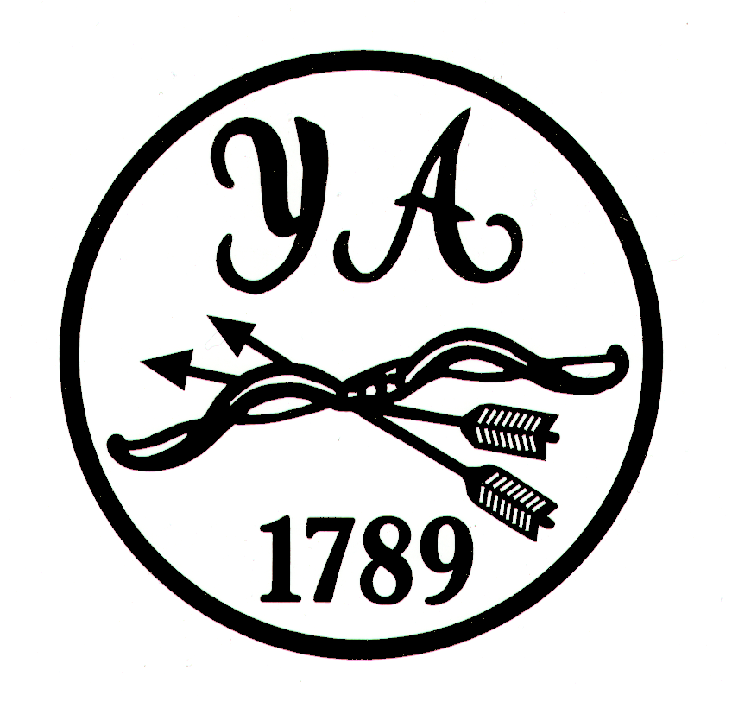

Yorkshire Archery Association

Constitution

March 2022

Constitution
This constitution, amended March 2022, shall in no way contravene the Constitution of the Grand National Archery Society trading as ArcheryGB, except in respect of Clause 14 (Proxy Voting). All shooting organised by the Y.A.A. or any of its members, must conform with the Rules of Shooting laid down by the Grand National Archery Society. The Y.A.A. shall follow policies and procedures required by the G.N.A.S.

###

Clause 1 - Name
The Society shall be called the Yorkshire Archery Association (hereinafter referred to as “The Association”).

Clause 2 - Address
The postal address of the Association shall be that of the Secretary for the time being, or such other address as may be decided by the General Committee from time to time.

Clause 3 - Objectives
The objectives of the Association shall be the promotion and encouragement of Archery throughout the County known as Yorkshire as currently defined geographically.

Clause 4 - Membership
Any archery club whose Indoor or Outdoor facilities are in Yorkshire will become a member of the Association on paying the appropriate fees to the Grand National Archery Society, to the Northern Counties Archery Society and to the Association under the procedure for payment laid down from time to time. Members of such club will become associate members of the Association. Individual memberships shall be available to archers resident in Yorkshire, or archers who are members of YAA affiliated clubs, and who are members of GNAS, at a membership subscription to be laid down from time to time.
Individual memberships shall be available to non-shooting volunteers, resident in Yorkshire, or who are members of YAA affiliated clubs, at a Membership Subscription to be laid down from time to time.
Where Clubs are established as separate entities for special purposes (e.g. Junior or Disabled clubs) but the membership is totally included within that of a “parent” club, then only the “parent” club shall be permitted to provide a Club vote or exercise other Club rights as defined elsewhere in this Constitution. However, where the Secretary
of the Association is required to communicate with “all Club Secretaries”, the Secretaries of these clubs shall receive such communication.

Clause 5 - Misconduct.
If, in the opinion of the General Committee, any associated club or associate member shall have been guilty of conduct prejudicial to the interests of archery in the County or elsewhere, the General Committee may expel such club or member from membership of the Association without being called upon to state the reason to any but those concerned. Should the expelled member wish to appeal against the General Committee’s decision, an Appeals Committee of three shall be appointed to hear the appeal and their decision shall be final. In their deliberations they may examine such witnesses, and hear such evidence as they consider necessary. No member of the General Committee shall serve on the Appeals Committee.

Clause 6 - Management
The management of the Association’s affairs shall be entrusted to the General Committee, which shall consist of;-
- The President
- The two Vice Presidents
- The Chairman
- The Secretary
- The Treasurer
(The above posts will be referred to as the Executive Officers and must be six separate persons)

- The Target Tournament Officer
- The Coaching Organiser
- The Public Relations Officer
- The Junior officer
- The Clout Officer
- The Field Officer
- The Judges Liaison Officer
- The Minutes Secretary
- The County Target Teams Co-ordinator

(The above posts will be referred to as Officers, and should ideally be nine separate persons. Where at any AGM any of the above posts are not filled, a member of the Committee will be asked to take a lead role for that activity, until such time as a person is recruited to fill that post).

The Executive Officers and Officers shall be elected at the Annual General Meeting and shall hold office for two years; they shall be eligible for re-election. The President, one Vice-President, Chairman, Target Tournament Officer, Coaching Organiser, Public Relations Officer, Minutes Secretary and Field Officer shall be elected in one year, the second Vice-President, Secretary ,Treasurer, Junior Officer, Clout Officer, County Target Teams Co-ordinator and Judges Liaison officer in the next.
In addition to the above, the General Committee shall also consist of sufficient Ordinary Members to bring the Full Committee up to a strength of 25 members. These Ordinary Members shall be elected at the Annual General Meeting, and shall hold office for two years. One half of the Ordinary Members shall retire at one Annual General meeting and the other half in rotation at the next Annual General Meeting, but shall be eligible for re-election.

Only full members of the Association, having attained the age of eighteen, are eligible for election to the General Committee.

Nine persons, of which two shall be Executive Officers, shall constitute a quorum for meetings of the General Committee. Members of YAA who are not members of the Committee, attending for a specific purpose, may not be included in the quorum.

Clause 7 - Casual Vacancies
Any casual vacancy arising on the General Committee may be filled by the General Committee at any of its meetings. Any Executive officer, officer, or Member so co-opted shall have voting rights and shall retire at the next Annual General Meeting but shall be eligible for re-election.

Clause 8 - Sub-Committees
The General Committee shall have the power to appoint sub-committees for special purposes from its own members and may co-opt additional members for such sub-committees from outside its own membership. The Committee may delegate powers to such sub-committees, with defined limits, and such sub-committees shall be dissolved on the fulfilment of the purpose for which they were formed. Sub-Committees will normally report their findings back to the General Committee before any actions can be taken unless this power was delegated to the sub-committee; only the General Committee can take any actions on findings that would result in the expulsion of a club or member. Members of the General Committee may form an Appeals Sub-Committee unless this conflicts with Clause 5.

Clause 9 - Financial
All funds and property of the Association shall be vested jointly in the President, Chairman, Secretary and Treasurer. Cheques, withdrawals from bank to accounts and any financial transaction involving the disposal of the Association’s funds or property shall require the signatures (electronic or otherwise) of two of the Executive officers nominated as authorised signatories.

Clause 10 - Emergency Committee
In cases of emergency, where it is impossible or impracticable in the chairman’s opinion to call a General Committee Meeting in time, the Chairman, Secretary and Treasurer shall have full powers to act.

Clause 11 - Selection Committee
The Target Selection Committee shall consist of the Chairman, Secretary, and the County Target Team Co-ordinator. The decisions of the Target Selection Committee are final. However, the General Committee may call upon the Target Selection Committee to explain its selections formally at a meeting of the General Committee, for the explanation to be recorded.

The Target Selection Committee shall only be called into operation in exceptional circumstances. Senior and junior teams will be selected for the normal Representative Matches, mainly “the Inter-Counties”, based on the system of merit of submission of scores by archers for the current year. The Committee will be informed of the archers being selected.

Clause 12 - Annual General Meetings
a) The Annual General Meeting of the Association shall be held at a time and place to be fixed by the General Committee. It will be held each year on a date between 1st March and 31st May. Notice of an Annual General Meeting shall be given in writing to all Club Secretaries at least twenty-eight days before the date of such a meeting. In writing means written, or printed or lithographed, or partly one and partly another, and other modes of representing or reproducing words in a visible form, including electronic communications.

b) The business to be transacted at an Annual General Meeting shall be the receiving of the Annual Reports of Officials and Statement of Accounts, the election of the Executive Officers, Officers, and Members, and such other business as may be brought before an Annual General Meeting, and which has been notified in writing to the Secretary by 31st January.
c) If the Annual General Meeting is inquorate (see Clause 14), the existing General Committee shall remain in place. A Special General Meeting (see Clause 13) shall be called to carry out the business of the inquorate AGM.

Clause 13 - Special General Meetings
The General committee may, or at the request of not less than twelve Associated Members from not less than three Associated Clubs, require the Secretary to convene a Special General Meeting of the Association. In such circumstances, the Secretary shall forthwith convene such meeting by giving not less than twenty-one days notice to the Secretaries of all Associated Clubs. The notice shall state the object for which the Special General meeting is convened, and only such business may be dealt with at such meeting.

Clause 14 - Voting at General Meetings
Fifteen members present in person (at least two of which shall be Executive Officers) at a General Meeting (as defined in Clauses 12 & 13) shall form a quorum. At all General Meetings each Associate Member present, including Committee Members and Officers, having attained the age of 18 years, shall be entitled to only one vote. No proxy voting shall be permitted. No person may vote in more than one capacity. In the event of a tie, the Chairman shall have the casting vote. At any vote, a simple majority of the votes of those present, entitled to vote, and not abstaining shall decide the issue, except as otherwise required by this Constitution.

Clause 15 - Championships
The Association shall hold once in each year a Target Championship Meeting and any other meetings it requires.

Clause 16 - Accounts and Audit.
The Association’s financial year shall end on 31st December. The General Committee shall cause proper accounts of Receipts and Payments to be kept by the Treasurer. The Treasurer shall prepare and complete the Association accounts, for the previous financial year, by the 31st January. The Accounts shall then be presented to the elected Validator, who shall validate the accounts, such as to enable a Validated Statement of the financial affairs of the Association to be presented to the Members at the Annual General Meeting. The Validator, who shall be a member of the Association, preferably not a member of the General Committee, shall be elected for the purpose at the previous years’ Annual General Meeting. Should it not be possible to elect such a person at the AGM, then two members of the General Committee shall be appointed to validate the accounts.

Clause 17 - Alterations to Constitution and Rules
No alterations shall be made to the Constitution and Rules of the Association except at a General meeting. Due notice of the proposed alterations shall be given to Club Secretaries in accordance with Clause 12(a) and (b). Such proposal must be carried by a minimum of two thirds majority of the votes cast, and, if carried, shall normally be effective from the closure of the meeting; as an exception, the General Committee may decide that time may elapse before the proposal is effective, in order to inform the members.

Clause 18 - Members of Two or More Clubs
Within the United Kingdom an archer may belong to, and shoot for, more than one club in any one given Discipline in any one affiliation year; but the Club through which the archer’s Grand National Archery Society affiliation fee is paid shall be the “first claim” club. Only by agreement with that Club may an archer represent another Club at any Club or Inter-Club event.

The Disciplines being Outdoor Target, Indoor Target, Field, Fight, Clout, and Popinjay Archery.

The archer may represent only the “first claim” club at County, Regional, or National events.

Clause 19 - Dissolution
Any measure for the dissolution of the Association, or for its amalgamation with or absorption by any similar Association or Society other than the existing Northern Counties Archery Society, or for the alteration of the existing geographical boundaries shall be a matter for decision at a Special General Meeting called for the purpose. Any motion connected with these matters at such a meeting must be passed by a majority of two-thirds of the votes cast.
In the event of dissolution of the Association, after discharging all debts and liabilities of the Association the remaining assets shall be given or transferred to some other voluntary organisation having objectives similar to the Association’s. as determined at the SGM.

Clause 20 - Election of Representatives to Northern Counties.
The election of representatives to Northern Counties shall be dealt with by the general Committee at the first meeting following the Association’s Annual General Meeting.

Clause 21 - Honorary Life Members
If the Association wishes to honour any of its members for distinguished service in the cause of archery, it may elect such a person as an Honorary Life Member at the Annual general meeting. Nomination for such an election shall, in the first place, be made to the Association’s General Committee by 31st January. The number of Honorary Life Members shall be determined by the General Committee from time to time.

Clause 22 - The Yorkshire Sword
The Yorkshire Sword, presented in memory of Eric Strickland and Phil Simpson, shall be awarded annually to a Yorkshire Archer (that is, an affiliated member of the Association) who, in the opinion of the Clubs & Committee Members of the Association, has made the greatest service to Archery in Yorkshire in the previous year. Nominations for the Yorkshire sword, from Yorkshire Clubs & individual Committee Members only, are to be received by the Secretary, in writing, no later than December 31st. All nominations must be supported by a citation.
After consideration of nominations by the General Committee, the Secretary shall distribute copies of all appropriate nominations to all Association Committee Members and Secretaries of Yorkshire Clubs by March 1st. Clubs & YAA Committee Members shall each be allowed a single vote for one nominee, and a response is to be received by the Association Secretary no later than April 1st for ratification by the General Committee.

Clause 23 - Award of Merit
An Award of Merit, being the highest award which the YAA can bestow on any individual, shall be presented by the General Committee to any Associated Member who has given exemplary service to archery in any sphere of the sport. i.e. performance, administration, coaching, development of the sport etc. Nominations for the Award of Merit, from Clubs, should be sent in writing to the Association’s Secretary, accompanied by a citation, for consideration by the General Committee.

Clause 24 - Discretionary Power
Discretionary power is given to the General Committee to decide any circumstances not covered by this Constitution.

Clause 25 - Failure to Attend Committee Meetings
Any member of the General Committee, whether Executive Officer, Officer, or Member, who fails to attend three Committee meetings (not necessarily consecutive) without presenting apologies in advance to the Secretary, or giving an acceptable explanation of absence, shall automatically cease to be a member of the Committee from the third meeting missed. Such a member shall not be eligible for election to any post of the Association for a minimum of two years; this period may be extended by the General Committee.

Clause 26 - Policies and Rules
All members of the Association shall accept the jurisdiction of the Grand National Archery Society, the Northern Counties Archery Society and the Association, and shall conform to the Conditions, Policies, Rules and Shooting Regulations as may be determined by these bodies from time to time.

Clause 27 - Safeguarding Officer
The Association shall appoint, from among its membership, a Safeguarding Officer and a Deputy Safeguarding Officer, with powers to carry out the roles and duties of such officers as described in the GNAS “Safeguarding Children and Young People Policy” in force at the time. These officers shall be appointed at such time as to ensure that both posts are filled continuously as far as is practical.

These officers need not be appointed from within the General Committee; the General Committee shall have approval of these appointments. These officers shall be expected to attend meetings of the General Committee (and sub committees) if requested, and shall have the right to attend meetings of the General Committee (and sub committees), and to address them, but shall have no ‘ex-officio’ voting rights.

The appointment of these officers shall be notified to members as appropriate as soon as possible after the appointment. The appointments need not be for a specified period, though the General Committee must confirm them, at least annually. The Association shall reimburse reasonable training and operating expenses.

Clause 28 - The Yorkshire Award
The Yorkshire Award shall be presented by the General Committee to a Yorkshire Archer or Couple (that is, who are affiliated member(s) of the Association) who has done exemplary work within or on behalf of their particular club, over a number of years. Nominations for the Yorkshire Award, from Clubs, should be sent in writing to the Association’s Secretary, accompanied by a citation, for consideration by the General Committee.

Amendments to Constitution
Clause 4 Clarification about facilities being in Yorkshire: AGM 2002
Clause 6 Division of Flight & Clout Officer role. Changes to number of General Committee; AGM 2002
Clause 6 Introduction Field Officer & Committee strength to 25; AGM 2004
Clause 16 Internal validation by members of Association; AGM 2004
Clause 26 Policies & Rules introduced; AGM 2004
Clause 27 Child Protection Officer introduced; AGM 2004
Clause 22 Changed to include Committee Members to nominate and vote. AGM 2005
Clause 16 Changed to introduce validation before AGM and election of Validator to validate the following years’ accounts. AGM 2006.
Clause 19 Changed to describe transfer of assets on dissolution. AGM 2007
Clause 28 New Clause to introduce “The Yorkshire Award”. AGM 2007
Clause 23 Changed to require written citation and to set the scale of the Award. AGM 2007
Statement pre-Clause 1 Requirement to review Constitution removed. AGM 2010
Clause 6 Changed to delete Flight Officer and introduce Minutes Secretary & County Target Team Co-ordinator. AGM 2010
Clause 11 Changed to introduce CTT Co-ordinator and to reflect selection process based on score submissions. AGM 2010
Clause 14 Changed to reduce quorum numbers from 25 to 15. AGM 2010
Clause 8 Changed to allow sub-committees to implement a decision AGM 2014
Clause 12 Changed to define electronic communications as in the GNAS definition
Clause 4 Add individual membership for non-shooting volunteers AGM 2015
Clause 4 Clarify membership is available to Yorkshire residents or members of Yorkshire clubs
Clause 27 Modify to Safeguarding from Child Protection AGM 2017
Preamble Clarify GNAS is ArcheryGB and YAA will follow required policies AGM 2017
Clause 9 Add President as additional signatory and prepare for electronic signatures AGM 2020
Clause 9 Remove number of authorised signatories to reflect the number allowed by different banks – two are still required to authorise.

